Whittonstall Community Band

Trustee’s Report and Financial Statements

For the year ended

31 December 2018

Contents

Reference and Administration Details 3
Structure, Governance and Management 3
Trustees’ Report 4
Financial Statements 5
Ultimate Controlling Party 8

Reference and Administration Details

Name:
Whittonstall Community Band (WCB, the ‘Band’)

Charity
Due to the level of income Whittonstall Community Band is not required to register with the Charity Commission, however the Band has voluntarily registered with HMRC, charity reference EW37689

Trustees:
Mrs J Holmes (Vice Chair)
Mr A Spencer (Chair)
Mrs C Spencer (Secretary)

Registered Address: Bankers:
The Old Vicarage The Co-operative Bank plc
Whittonstall PO Box 101
Northumberland Balloon Street
DH8 9JN Manchester
M60 4EP

Structure, Governance and Management

Whittonstall Community Band is a small charity governed in accordance with the Constitution document which was formally adopted on the 16 February 2015.

The Band’s activities are overseen by its board of volunteer trustees.

Appointment of New Trustees
The Band’s Constitution requires a minimum of three and a maximum of ten trustees to be appointed. New trustees can be appointed at any time, but must retire at the first Annual General Meeting at which point they may be re-elected.
New trustees must be willing to act as trustees and are required to comply with the requirements as set out in the Band’s Constitution document and the relevant legislation governing charities.

Induction and Training of New Trustees
All Trustees are familiar with the Charity Commission’s publication “The Essential Trustee” and have access to training materials provided by the NCVO.

Organisational Structure
The trustees meet regularly and are responsible for ensuring that the Band meets all the required legal obligations of a charity. The trustees also ensure that policies and procedures are established and reviewed on a regular basis. The trustees are supported by volunteers who help with the organisation and co-ordination Band activities.

Related Parties
Whittonstall Community Band is an independent charity with no links to any related parties.

Trustees’ Report

Objectives and Activities for the Public Benefit
The Trustees ensure that all activities undertaken are for the public benefit and in accordance with the objects in the Constitution as follows:

- To advance public education in the appreciation of the art of music by the presentation of concerts and other musical activities.
- To advance community involvement and training in the art of music.

Risk Management

The Trustees recognise the uncertainty over future income as the main risk facing the charity. The Band will actively seek additional financial support and will engage in fundraising activities to support the on-going development of the Band.

Financial Review
The band has received and continued to receive generous support from the RWE Innogy UK Kiln Pit Hill Wind Farm Community Fund via the Community Foundation, the County Durham Community Foundation and the Co-op Local Community Fund, and is very grateful for the help and support received from the local community.

Reserves Policy
The Board of Trustees has examined the charity’s requirements for reserves in light of the main risks to the organisation. The intention is to hold a small sum as reserves sufficient to ensure that the charity can cover one month’s expenditure.

The trustees regularly review the reserves position, with a formal review undertaken on an annual basis.

Investment policy and objectives

WCB does not hold any investments. In the event that sufficient funds were available monies would be deposited in the charity’s bank account.

Approved by the members and signed on their behalf on 11/1/2020:

Name: A Spencer

Financial Statements

Compilation Report
Whittonstall Community Band
For the year ended 31 December 2018
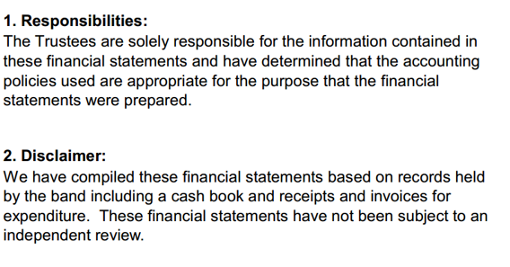

C Theobald
Treasurer

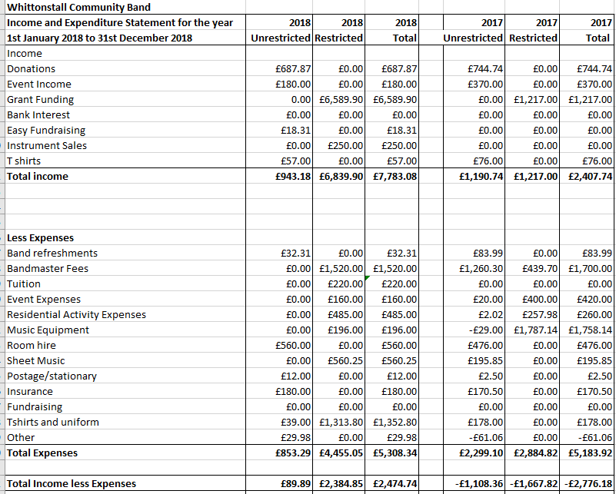
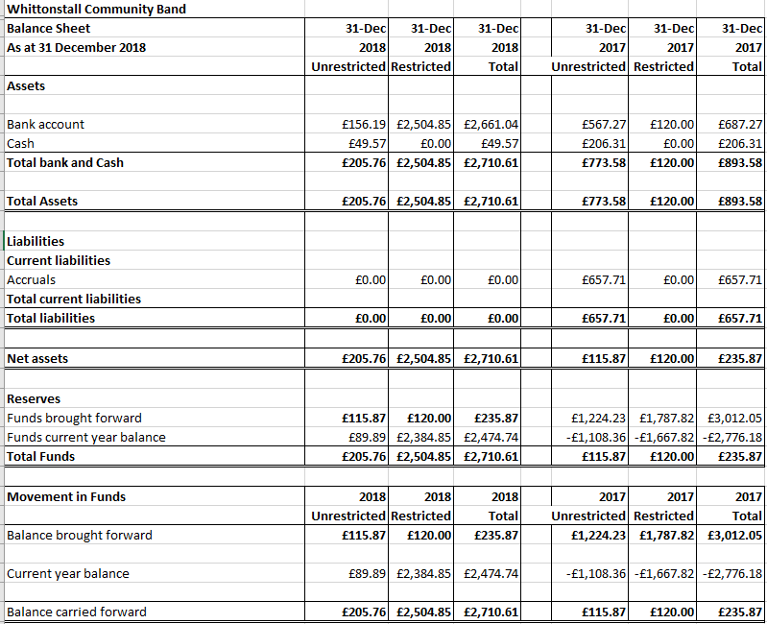

Notes to the Financial Statements
Whittonstall Community Band
For the year ending 31 December 2018

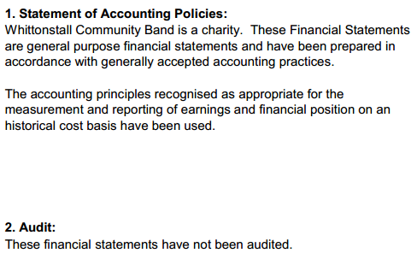

Ultimate Controlling Party

The charity is under the control of the Trustees.

